Researchers discover what lies behind the death of stem cells

by Francesca Davenport16 September 2014
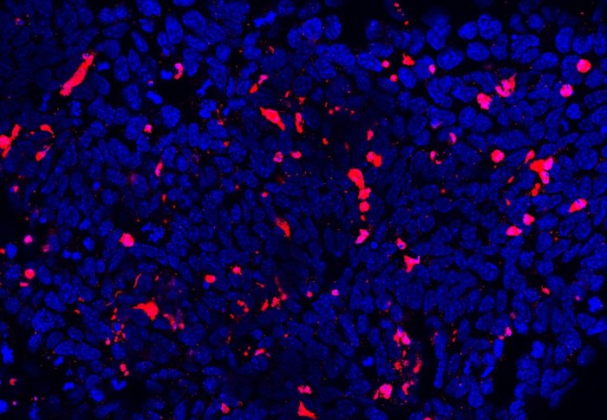
Image showing stem cells dying (in red) due to lack of
microRNAs
Researchers have identified key processes that control stem cell survival, providing insights that could improve their use in medicine.
The study, recently published in Genes and Development, revealed that small molecules called microRNAs play a key role in controlling the death and survival of pluripotent stem cells. These cells, found in embryos, have the potential to develop into almost any cell in the body, providing a possible source of healthy, renewable cells and tissues that could contribute to the treatment of a range of diseases.
Understanding the normal processes that lead to the death of these stem cells could help maximise the benefits of stem cell therapy for diseases such as Parkinson’s, Alzheimer’s and stroke and offer important information on how cancer cells become resistant to death.
Pluripotent stem cells are formed in the embryo about four days after fertilisation. Before the embryo implants in the womb lining they have no defined role, but after implantation they become more geared up for a specific job.
With a better understanding of the mechanisms that decide which cells live or die we could in the future potentially select only the healthy stem cells that are the fittest to use in regenerative medicine.
– Dr Tristan Rodriguez
Senior Lecturer
During this stage, the cells divide more quickly and are more liable to mutate or become defective. Mutations are usually detected by checking procedures within the cell that result in the death of defective cells.
Lead author on the study, Dr Tristan Rodriguez from theNational Heart and Lung Institute, Imperial College London said: “Until now the mechanisms that control the level of death and survival in stem cells have not been well understood. We had some of the pieces of the jigsaw but we really needed to put these together to get a clearer picture, which is what we have done in this study.
“With a better understanding of the mechanisms that decide which cells live or die we could in the future potentially select only the healthy stem cells that are the fittest to use in regenerative medicine. Our findings could also have implications for cancer treatment since cancer cells develop in a reverse fashion to stem cells by becoming less specialised and more resistant to cell death. If we can identify what governs cell death in stem cells we could also potentially find ways to break down this resistance in cancer cells.”
Previous work involving some of the researchers from this study has demonstrated that microRNAs play an important role in controlling stem cell death and survival. MicroRNAs are short sections of genetic material that have important roles in regulating gene activity.
The researchers investigated which microRNAs were most active when pluripotent stem cells are getting ready to specialise and are more susceptible to death. Measuring the activity of hundreds of microRNAs in mouse embryos, they identified three microRNA families that account for most of the activity.
In order to investigate the effects of ‘removing’ these microRNAs, the researchers deleted a gene that is essential for the formation of microRNAs. This loss in microRNAs led to the death of stem cells in the early embryo, confirming the role of microRNAs in the control of cell survival at this stage.
It was a real detective story to find the target protein of these microRNA families. We had to consider all the different pathways and influences involved in cell death.
– Dr Barbara Pernaute Lomba
Research Associate
To complete the picture the researchers identified that a protein called BIM is a target of the microRNA families they investigated in the study. As the activity of the microRNA families decreased, the levels of BIM increased and this induced the stem cells to start dying. This suggests that microRNAs appear to ‘fine tune’ levels of the protein BIM, allowing the balance of cell death and survival to be altered rapidly or ‘priming the stem cells for death’.
First author on the study Dr Barbara Pernaute Lomba also from the National Heart and Lung Institute at Imperial College London said: “MicroRNAs are more subtle in how they take effect than genes which switch on and off. They hunt in packs and those with the same function belong to the same family. This makes it very difficult to unpick exactly how they take effect and it was a real detective story to find the target protein of these microRNA families. We had to consider all the different pathways and influences involved in cell death. There were a lot of suspects but, after five years, we eventually managed to identify the BIM protein.”
The research was funded by the Medical Research Council (MRC) and conducted in the laboratories or the British Heart Foundation Centre for Research Excellence at the National Heart and Lung Institute, Imperial College London. Dr Pernaute Lomba is funded through the European Commission Marie Curie fellowship program and theEuropean Molecular Biology Organisation (EMBO) fellowship program
Reference: Pernaute et al. ‘MicroRNAs control the apoptotic threshold in primed pluripotent stem cells through regulation of BIM’ Genes & Development 2014 doi: 10.1101/gad.245621.114

